

CANDIDA AURIS QUALITATIVE PCR [C. auris] Collection Guide

Acceptable Specimen | 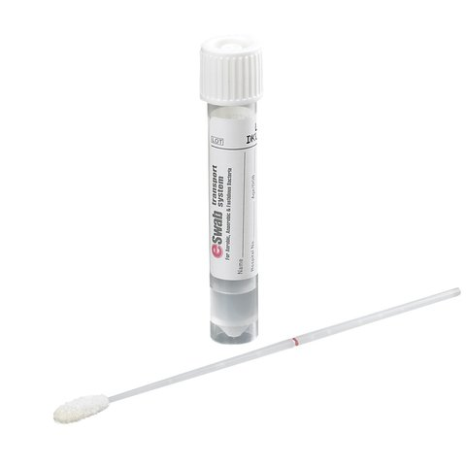  Combined Axilla/Groin Eswab  (BD Eswab Collection Kit, Lawson #202586)
Collection Instructions | - Remove the tube and swab from its packaging, careful not to touch the tip of the swab.  - Firmly rub all sides of the swab tip 5x over the left axilla skin surface followed by the right, targeting the crease in the skin.  - With the same swab used on the axilla, rub all sides of the swab 5x over the left groin skin surface followed by the right, targeting the inguinal crease in the skin where the leg meets the pelvic region.  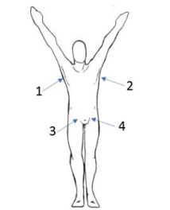  Image: Pennsylvania Bureau of Laboratories (PA BoL)  - Remove the cap from the collection tube and insert the swab.  - Snap off the end of the swab at the scored line by bending the swab against the side of the collection tube.  - Return the cap and ensure that the collection tube is tightly sealed.  - Label the Eswab container with the appropriate label.

