Contact the laboratory for minimum sample volumes
- All tubes must be gently inverted 8-10 times
- Unless otherwise specified, preferred sample volume for all testing is a full tube
 | Container/Tube | Additive | General Information | Notes
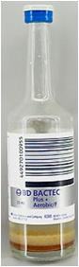  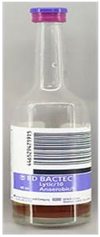 | Bactec - A  Blue top  Aerobic Blood Culture bottle  Bactec – N  Purple top  Anaerobic Blood Culture bottle | Aerobic  Anaerobic | Optimal volume of blood is:  8-10 mLs/per bottle  16-20 mLs/per set | - Collect Aerobic  first  - A blood culture set is considered  1 Aerobic &  1 Anaerobic  - Each blood  culture set should be the same collection time  - Two blood  culture sets must be drawn at two different collection times  and when possible 2 different sites.
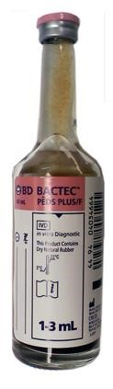 | Bactec - P  Pink top  Aerobic Blood Culture Bottle | Aerobic | Pediatric Blood  Culture  1-3 mLs

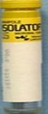 | Isolator | Sterile | AFB Blood  Culture  Fungal Culture
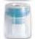  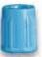 | BLUE  Light Blue | 3.2% Sodium  Citrate | Coagulation testing  PT, PTT | MUST BE FULL TUBE ** When using butterfly device to collect light blue top, always clear the tubing using a clearing tube.
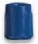 | RBLU(-)Add Dark Blue  No additive | No Additive | Referral Testing  i.e.,  Special  Chemistry collections
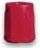 | RED  Plain red  With Additive | Clot Activator Plastic tube | Chemistry, Referral Testing
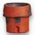  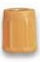 | SST Gold or Marbled | Clot Activator  SST - Serum  Separator Tube | Chemistry, Referral Testing
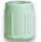 | Green/LI  Light Green | Lithium  Heparin  PST – Plasma  Separator  Tube with Heparin | Majority of General  Chemistries
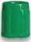 | Green/NA Dark Green | Sodium Heparin | Referral Testing  i.e., Bone marrow,  Chromosome studies
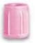 | Pink/BB Pink | EDTA / Potassium | Blood Bank  BB ID band may be required | No labeling correction  Allowed post collection
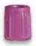 | Purple  Lavender | EDTA / Potassium | Hematology  testing, i.e. CBC, ESR
 | RBLU(+)Add  Dark Blue with additive | EDTA (Na2) | Referral Testing
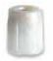 | White/PPT  White top PPT | Plasma Separator tube with  K2EDTA | Referral Testing  i.e.,  Special molecular  testing
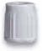 | Grey | Potassium oxalate / sodium fluoride | Lactic acid* | MUST BE FULL TUBE
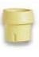 | Yel/ACDA Yellow ACD Type A | ACD Type A | Referral Testing  i.e.,  DNA /  Molecular testing
 | Yel/ACDB  Yellow ACD Type B | ACD Type B | Referral Testing  i.e.,  DNA /  Molecular testing

