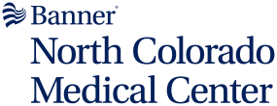
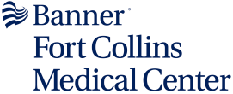
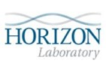

LSA Colorado/Nebraska laboratories provide full clinical testing services in Hematology, Chemistry, Microbiology, Blood Bank, Toxicology and Pathology. The NOCO Laboratories are open 24 hours a day, 7 days a week, serving routine and emergency needs of the hospital, physician's offices, clinics, and the community and performs most tests in-house. The remaining tests, consisting primarily of infrequently ordered tests, are sent to accredited reference laboratories, such as Sonora Quest Laboratories and Quest Nichols Institute.

Laboratory Locations
Banner Fort Collins Medical Center  4700 Lady Moon Drive  Fort Collins, CO 80528  (970) 821-4350  Fax: (970) 821-4346 | North Colorado Medical Center  1801 16th Street  Greeley, CO 80631  (970) 810-6400  Fax: (970) 810-6770
Horizon Laboratory  2555 E 13th Street, Suite 115 Loveland, CO 80537  (970) 820-6890  Fax: (970) 820-6927  Horizon Laboratory Locations  Direct Access Testing Information | NOCO Laboratory Information  NOCO Phone Numbers  Microbiology Billing Information

Laboratory Regulatory and Accreditation Information
The laboratory participates extensively in proficiency testing programs of the College of American Pathologists (CAP) as well as other specialized proficiency programs. Below are the Laboratory accreditations. To obtain copies of laboratory accreditation certificates, please reach out to the site directly at the phone numbers listed above.

Banner North Colorado Medical Center  CAP; CLIA | Banner Fort Collins Medical Center  CAP; CLIA | Horizon Laboratory at Skyline  CLIA

Reviewed 11/04/2025

