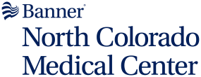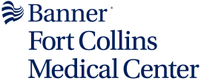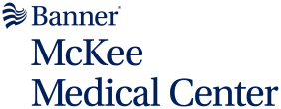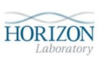

LSA Colorado/Nebraska laboratories provide full clinical testing services in Hematology, Chemistry, Microbiology, Blood Bank, Toxicology and Pathology. The NOCO Laboratories are open 24 hours a day, 7 days a week, serving routine and emergency needs of the hospital, physician's offices, clinics, and the community and performs most tests in-house. The remaining tests, consisting primarily of infrequently ordered tests, are sent to accredited reference laboratories, such as Sonora Quest Laboratories and Quest Nichols Institute.

**Laboratory Locations**

|  |  |  |
| --- | --- | --- |
| **Banner Fort Collins Medical Center**    4700 Lady Moon Drive  Fort Collins, CO 80528  (970) 821-4350  Fax: (970) 821-4346 | **McKee Medical Center**    2000 N Boise Ave  Loveland, CO 80537  (970) 820-4133  Fax: (970) 820-4159 | **North Colorado Medical Center**    1801 16th Street  Greeley, CO 80631  (970) 810-6400  Fax: (970) 810-6770 |
| **Summit View Medical Commons**    2000 70th Avenue  Greeley, CO 80634  (970) 810-2570  Fax: (970) 810-2575 | **Horizon Laboratory**    2555 E 13th Street, Suite 115 Loveland, CO 80537  (970) 820-6890  Fax: (970) 820-6927  [Horizon Laboratory Locations](https://www.horizonlaboratory.com/location-info/location-hours-info)  [Direct Access Testing Information](https://www.horizonlaboratory.com/direct-access-testing/direct-access-testing) | **NOCO Laboratory Information**    [NOCO Phone Numbers](https://jdos.nicholsinstitute.com/Dos/Download/northcoloradomedicalcenternoco/NoCo_Phone_Numbers-Updated072924.pdf)  [Microbiology Billing Information](https://jdos.nicholsinstitute.com/Dos/Download/northcoloradomedicalcenternoco/Micro_billing.pdf) |

**Laboratory Regulatory and Accreditation Information**

The laboratory participates extensively in proficiency testing programs of the College of American Pathologists (CAP) as well as other specialized proficiency programs. Below are the Laboratory accreditations. To obtain copies of laboratory accreditation certificates, please reach out to the site directly at the phone numbers listed above.

|  |  |  |  |  |
| --- | --- | --- | --- | --- |
| **Banner North Colorado Medical Center**  CAP; CLIA | **Banner Fort Collins Medical Center**  CAP; CLIA | **Banner McKee**  **Medical Center**  CAP; CLIA | **Summit View Laboratory**  CAP; CLIA | **Horizon Laboratory at Skyline**  CLIA |

Reviewed 05/23/2025