Transport container | Tests | Transport
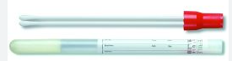  Red Copan swab with LQ Stuart | Eye culture or Genital culture  Fungal culture  MRSAPCR or MRSA culture  Nasal Complete PCR  Strep screen or Throat culture  Strep B OB/Gyne culture | RT delivery to lab within 24 hours
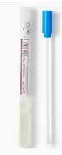  Blue swab Amies gel | Wound culture  Wet prep  Sinus culture | RT delivery to lab within 24 hours
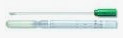  Green swab with mod. Stuarts | Nasopharyngeal culture  Urethral cultures | RT delivery to lab within 24 hours
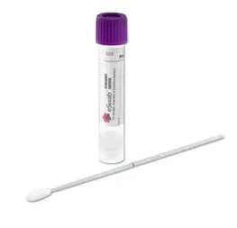  Purple E swab | Strep A PCR  Strep screen or Throat culture | RT delivery to lab within 24 hours
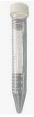  Sterile vial | FLU A/B antigen  SARS CoV-2 antigen  RSV antigen with Nasopharyngeal swab | RT delivery to lab ASAP.
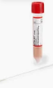  Copan UTM- Rt 3ml | SARS CoV-2 PCR | RT delivery to lab ASAP.
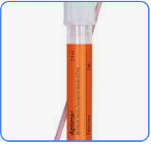  Aptima Multitest swab | Chlamydia and Neisseria gonorrhoeae CHLGCPCR  Bacterial vaginosis BV  Candida and Trichomonas CV/TV | RT delivery to lab within 24 hours
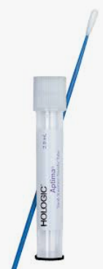  Endocervical or male urethral swab | Chlamydia and Neisseria gonorrhoeae CHLGCPCR | RT delivery to lab within 24 hours
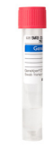  GeneXpert transport vial | Chlamydia and Neisseria gonorrhoeae CHLGCPCR  ER location only | RT delivery to lab within 24 hours
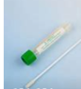  3 ml VCM/swab set  2 types: Nasopharyngeal & Lesion/other | Bordetella pertussis PCR  Herpes simplex virus 1and 2 PCR  Respiratory pathogen panel  Varicella zoster PCR | RT delivery to lab within 24 hours
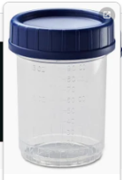  Sterile container | Body fluid culture (Bacterial, Fungal or AFB)  Sputum culture (Bacterial, Fungal or AFB)  Stool culture  Tissue/biopsy culture (Bacterial, Fungal or AFB)  Urine culture | Refrigerate and delivery to lab within 24 hours
Collection Swab Chart

G:\LAB\Collection Swab Chart.docx
Revised: 7/24/2024

