

Order of Draw for Blood Collection
Follow the correct order of draw to prevent cross-contamination between additives.

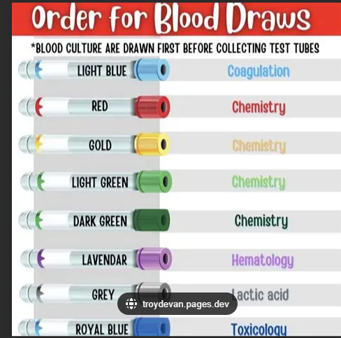
Note: Always draw blood cultures before any other tubes.

Tube Color | Department | Additive / Test Type
Light Blue | Coagulation | Sodium Citrate
Red | Chemistry | No additive (Serum)
Gold | Chemistry | SST / Clot activator
Light Green | Chemistry | Lithium Heparin / Plasma
Dark Green | Chemistry | Sodium Heparin / Plasma
Lavender | Hematology | EDTA
Grey | Lactic Acid | Sodium Fluoride / Potassium Oxalate
Royal Blue | Toxicology | Trace Elements (Heparin or EDTA)

