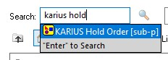
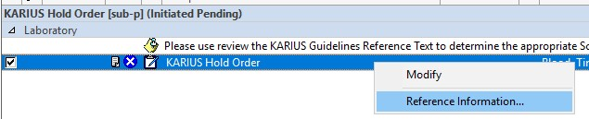
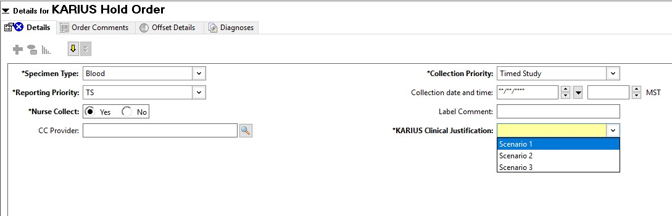
KARIUS ordering process:

Naming of the KARIUS Hold Order in Cerner PowerChart

Right click on the KARIUS Hold Order to Access the “Reference Information” that
explains the clinical scenarios
where testing would be appropriate (see attached document).

The provider should select the appropriate clinical scenario for their patient

according to the Reference
Information document.

- The provider will identify a patient that fits one of the 3 pre-approved clinical scenarios
  - The provider order the “KARIUS Hold Order” and provide the clinical scenario that matches their patient’s condition.

  - The patient’s specimen will be collected and sent to the lab for processing. After processing the plasma specimen, the lab will freeze the specimen and hold it for 3 weeks.
- The provider should assess the patient to determine whether directed sampling/specimen collection could be achieved to diagnose the infection (e.g., BAL collection, heart valve removal, etc.)
  - If the patient is not stable enough for sampling/specimen collection, the provider will order a “Laboratory Communication” asking the laboratory to send the held KARIUS specimen for testing.
  - NOTE: this “Laboratory Communication” order must be submitted within 3 weeks of the original
“KARIUS Hold Order.”
  - Laboratory will order the KARIUS testing (directly or through ESOT) and send the testing – no additional medical director approvals are needed.

